RECIPE
Beer Battered Shrimp Tacos
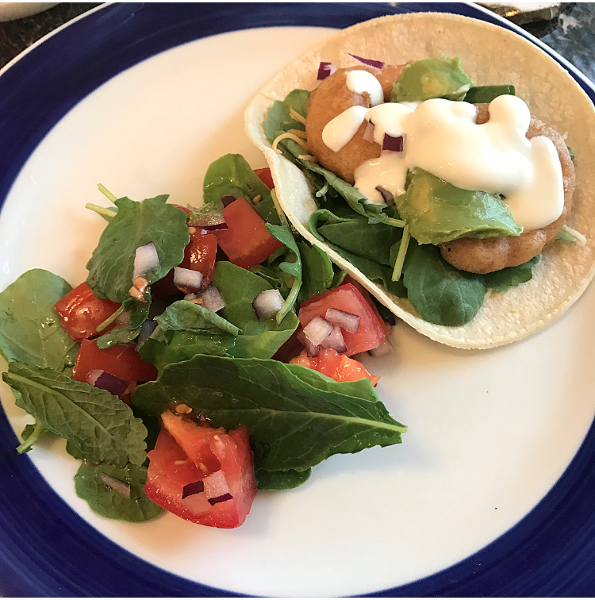
Ready in 40 minutes
Serves 6 people

Ingredients
Cream Sauce:
- 1/2 a cup sour cream
- 1 tablespoon of lime juice
Shrimp:
- 1 pound shrimp, peeled and deveined
- Salt, to taste
- 1/2 a cup white flour
- 1/2 a cup whole wheat flour
- 1 teaspoon garlic powder
- 1 teaspoon onion powder
- 1 teaspoon smoked paprika
- ¼ teaspoon taco seasoning
- ½ teaspoon baking powder
- 10 oz beer
- Oil, for frying
- For the tacos:
- corn tortillas
- Guacamole
Other topping ideas:
- red onion
- greens
- Cheese
- Tomatoes

Preparation
- Start by mixing the 1/2 a cup sour cream with 1 tablespoon of lime juice, let rest in the fridge.
- If necessary remove tails from shrimp then sprinkle with salt to taste.
- Mix all dry ingredients.
- Pour in 10 oz of beer and stir into dry ingredients.
- Add the shrimp into the batter
- Fill small pan with oil and heat medium/medium-high on stove top.
- Once oil is hot add a few shrimp at a time until golden brown.
- Remove and place shrimp on a paper towel lined plate.
- Repeat steps 7 and 8 until all shrimp are cooked.
- Heat corn tortillas according to the package. And then assemble tacos according to your preferences.

