RECIPE
Stove Top Apple Butter
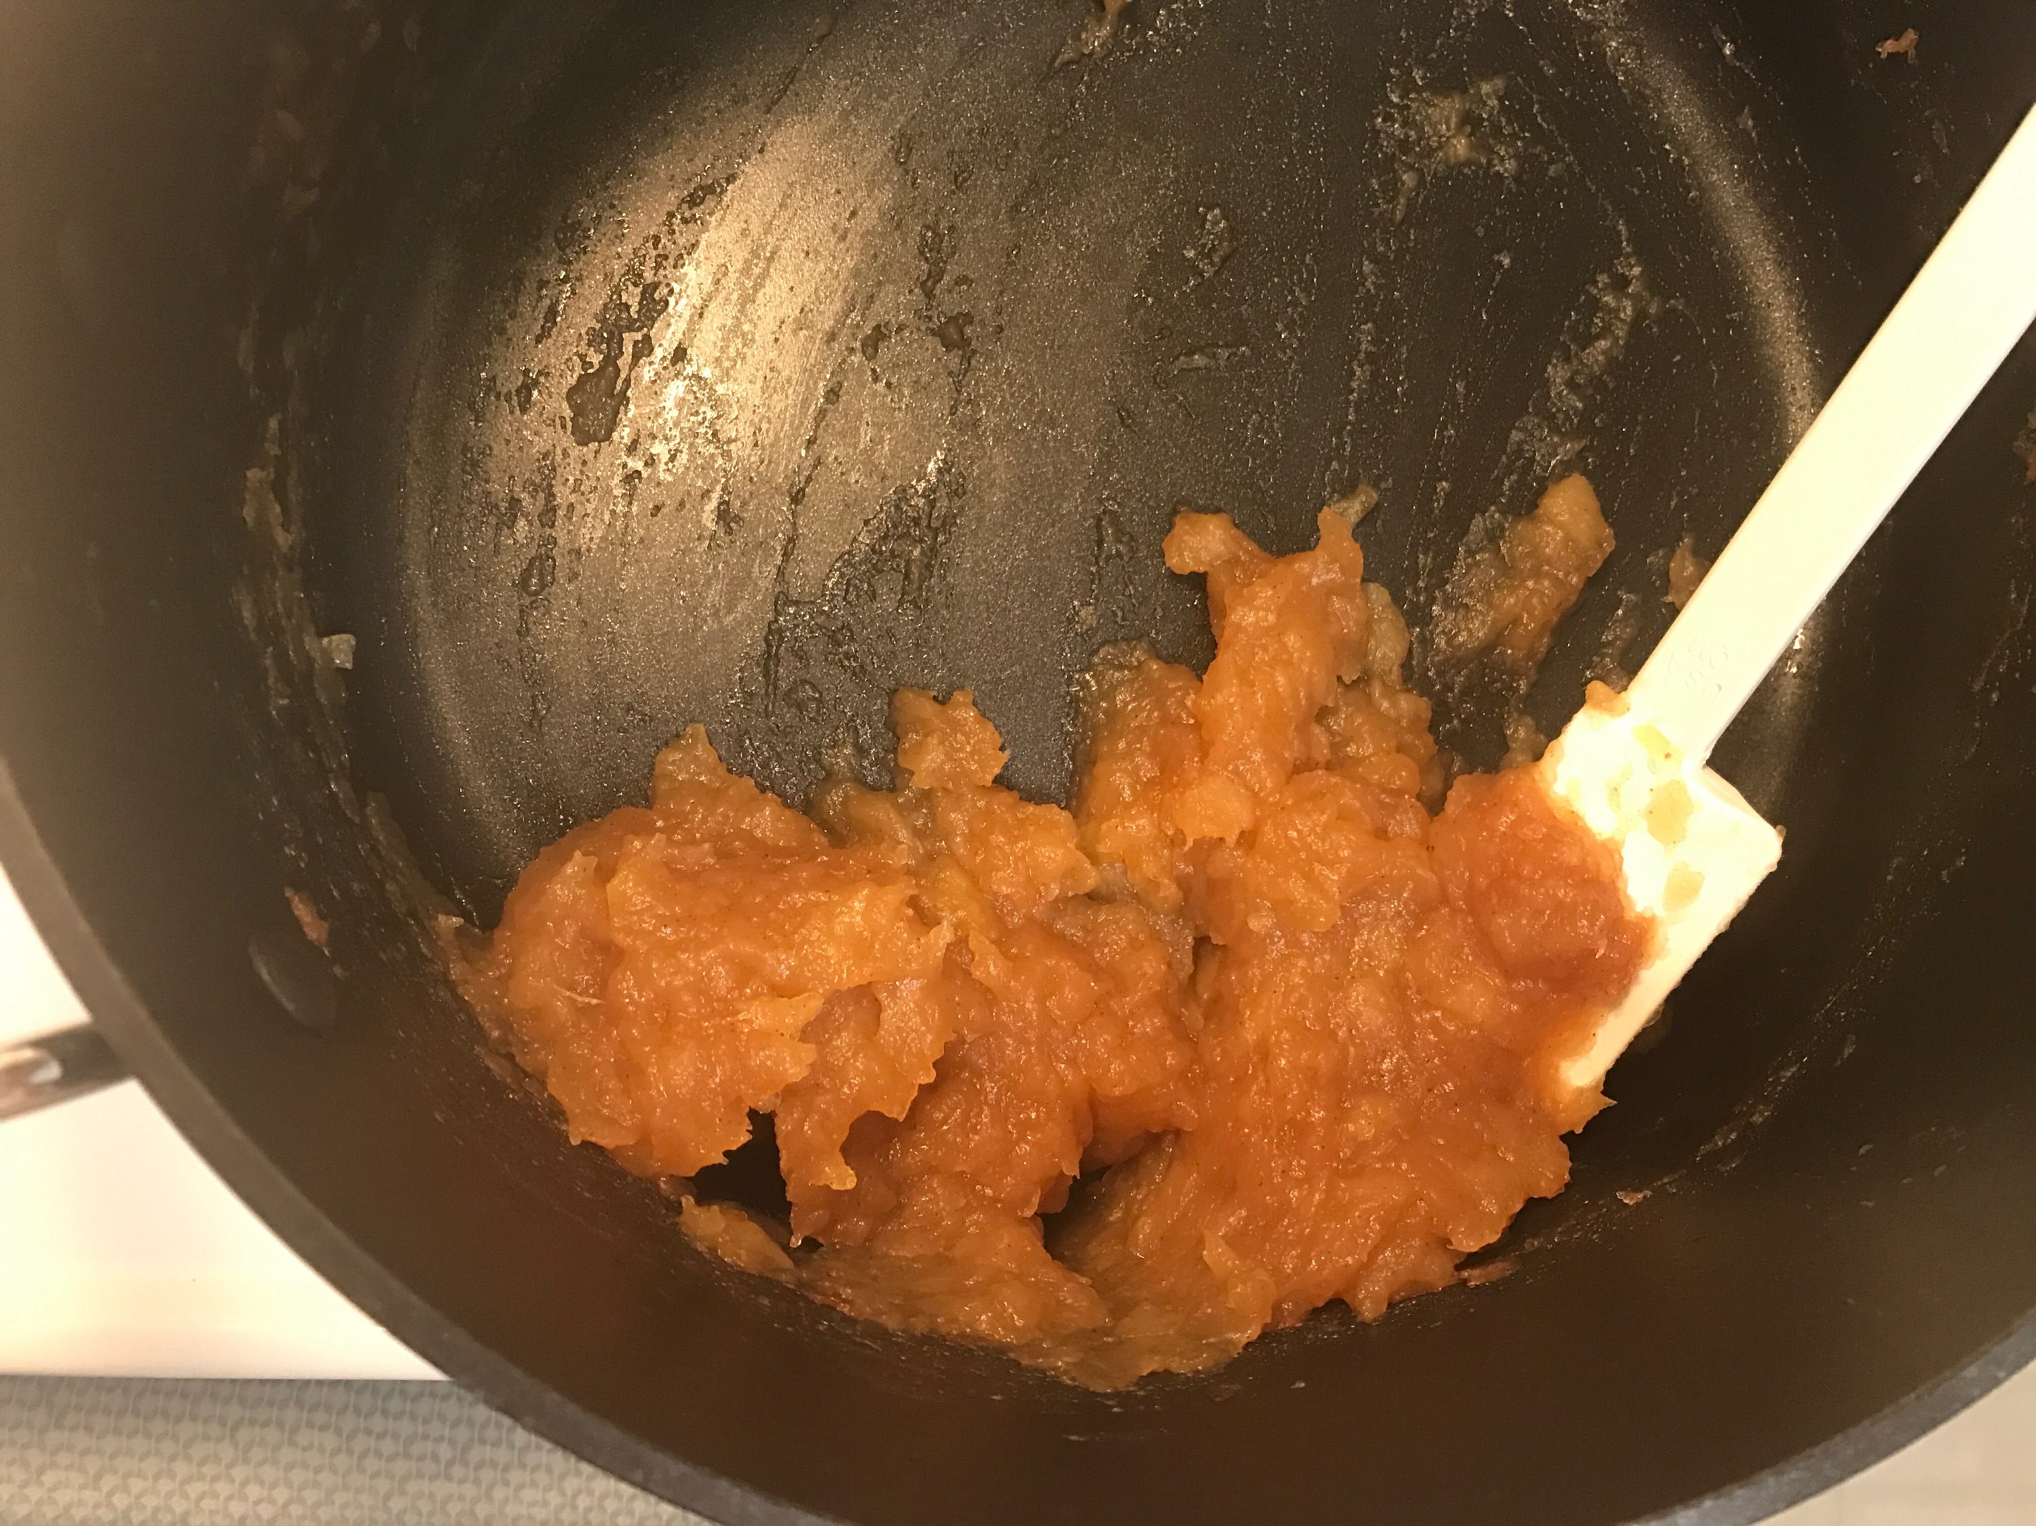
Ready in 2 hours

Ingredients
- About 2.5 pounds apples peeled and chopped
- 1/4 cup plus 1 Tbsp brown sugar
- 1 tsp cinnamon
- 2 tsp vanilla, divided
- 1/8 tsp nutmeg

Preparation
- Start by mixing the prepped apples in a large pot with ¼ of brown sugar, cinnamon, 1 tsp of vanilla and the nutmeg
- Covered the pot and start with medium-low heat
- After about 15-20 minutes. Stir and smooth mixture to the bottom of the pot. Then reduce to low heat
- After another 20 minutes add remaining brown sugar and vanilla then stir and smooth mixture to the bottom of the pot
- About 20 minutes later again stir and smooth mixture to the bottom of the pot
- After another 20 minutes if large apple pieces remain use a masher to mash these large pieces until they have the same consistency as the rest of the mixture. Smooth mixture to the bottom of the pot.
- After 10 minutes stir and smooth mixture to the bottom of the pot.
- After 10 more minutes the mixture should have the appearance of apple butter and be done
- Removed it form the heat and let it cool then transfer it into storage container

