RECIPE
Caramel Apple Snickerdoodles
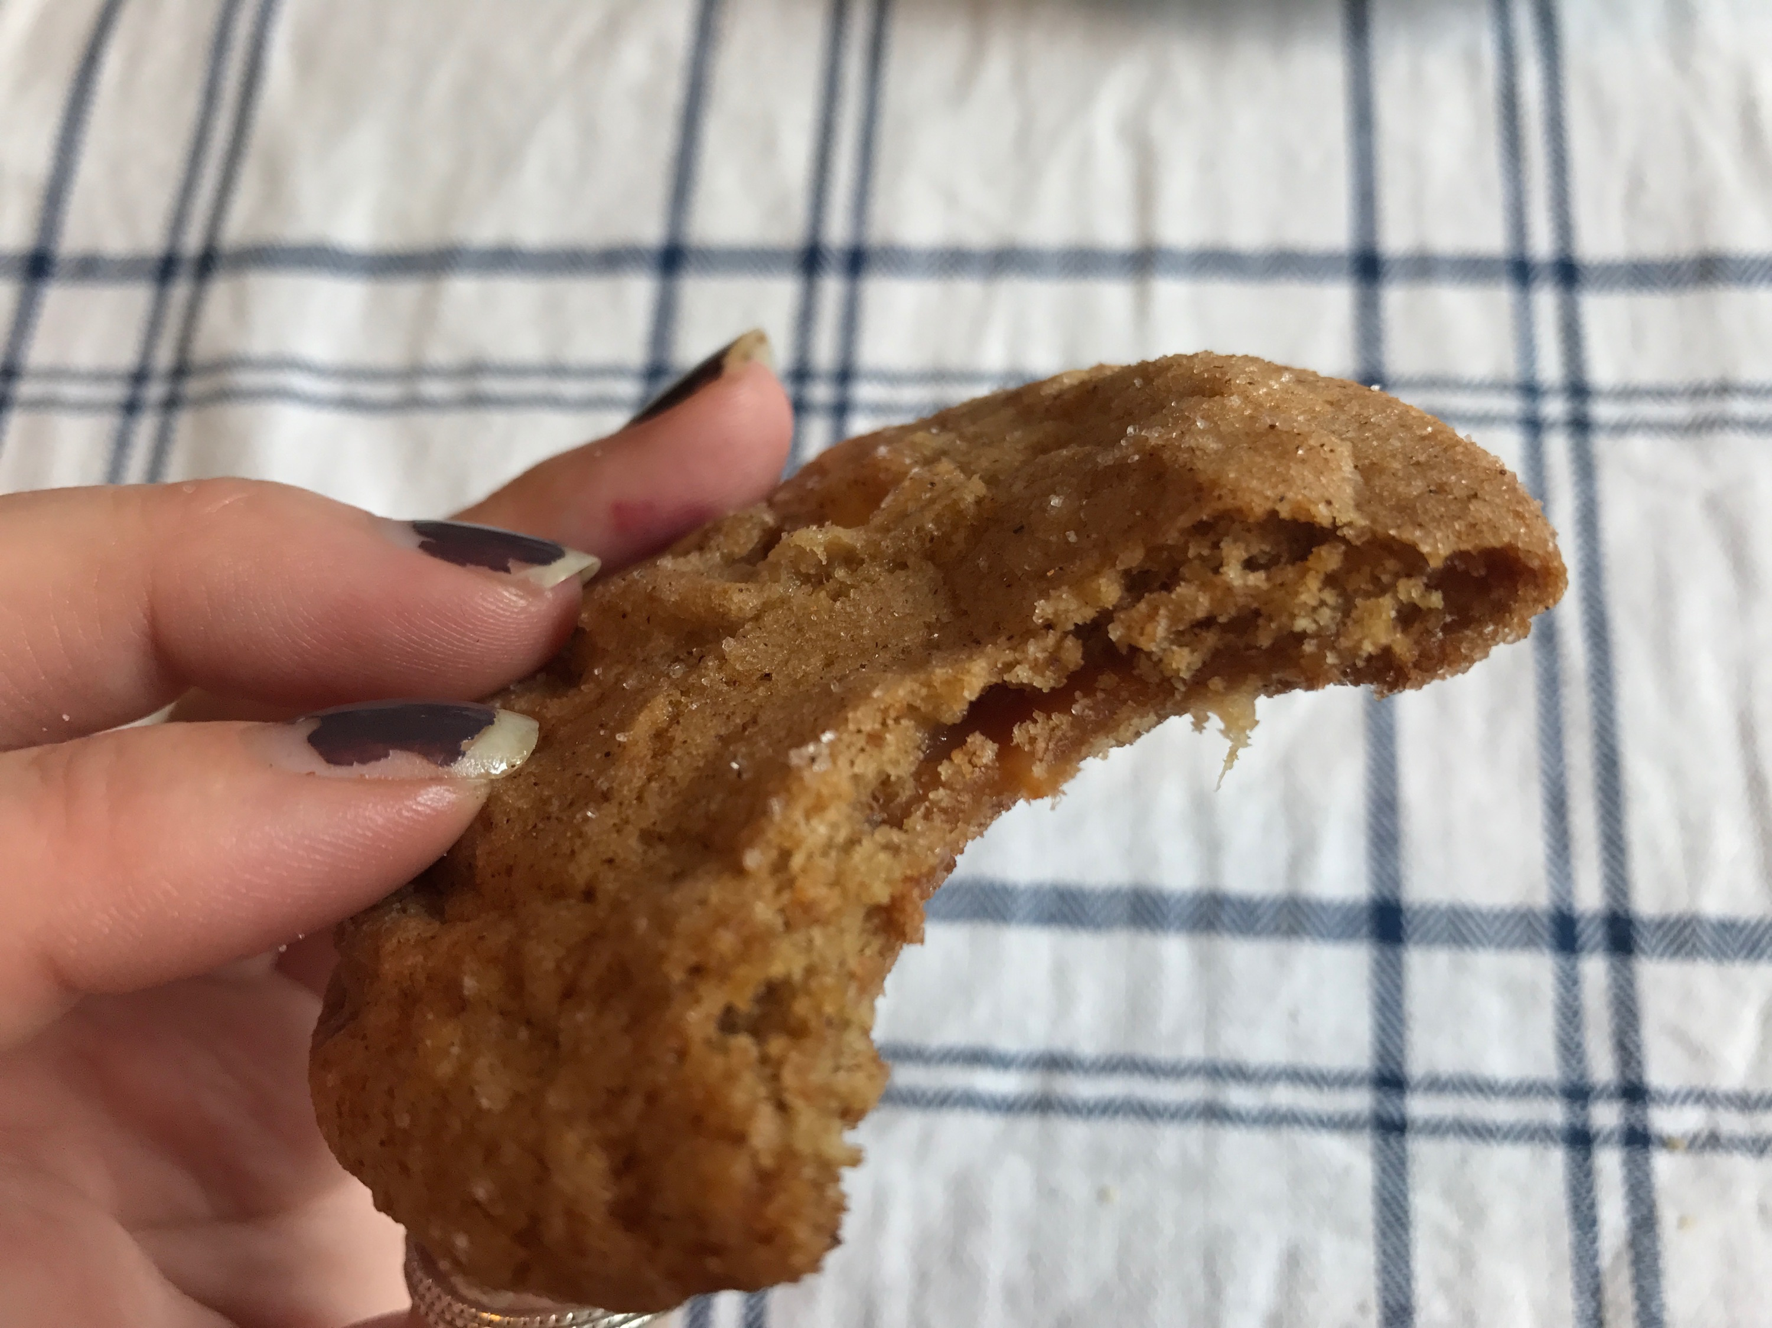
Ready in 2 hours

Ingredients
- 3 cups all-purpose flour
- 1 1/2 teaspoons baking powder
- 1 teaspoon baking soda
- 1 teaspoon salt
- 1 teaspoon cinnamon
- ½ teaspoon nutmeg
- 1 cup unsalted butter
- 1/2 cup granulated sugar
- 1 1/2 cups brown sugar
- 2 large eggs
- ¼ of a cup of apple cider
- 2 teaspoons vanilla extract
- 2 apples peeled and died
- 18-20 caramels, cut in half
- ½ cup of Sugar
- 2 teaspoons of cinnamon

Preparation
- Prepare apples and caramels
- Preheat oven to 325 degrees F. Line baking sheet with parchment paper and set aside.
- Whisk together flour, baking powder, baking soda, salt, cinnamon, and nutmeg. Set aside.
- Use a mixer to cream butter and sugars together.
- Add in the eggs, apple cider, and vanilla and mix, once combine use mixer to slowly add in the dry ingredients.
- Stir in the apples.
- Take about 2 tablespoons of dough in hand and then place a piece of caramel in the middle and wrap the dough around it.
- Mix remaining sugar and cinnamon in a separate bowl to roll the cookie ball in before placing on the prepared baking sheet, about 2 inches apart.
- Bake cookies for 10-12 minutes or until the edges are slightly golden brown. Remove from oven and let cookies cool on the baking sheet for 2-3 minutes. Transfer to a wire cooling rack and cool completely.

